(様式－7の1)

|  |  |  |  |  |
| --- | --- | --- | --- | --- |
| 課　長 | 副参事 | ﾁｰﾑﾘｰﾀﾞｰ | 主任監督員 | 監督員 |
|  |  |  |  |  |

|  |  |  |
| --- | --- | --- |
| 出　来　形　管　理　図　表 | 契　約  番　号 |  |
| （元号）　年　　月　　日  青森市公営企業管理者企業局長　様  住　所  受注者  氏　名　　　　　　　　　　印  （元号）　年　　月　　日に契約しました『○○地区配水管更新工事』の  下記事項について出来形管理図表を提出します。  記  1　工事数量表  2　平面図・配管立体図  3　オフセット図  4　掘削土工・土被り管理図表  5　埋戻工・路盤工・仮復旧工管理図表  6　路盤検査結果表  7　舗装工管理図表  8　オーバーレイ工管理図表  9　切取供試体厚さ測定管理図表 | | |

（様式-7の2）

1　工　事　数　量　表（例）　　　　　　　主任技術者　　　　　　　　　　印

現場代理人　　　　　　　　　　印

　　　　　　　　　　　　　　　　　　　　　　　　　　測　定　者　　　　　　　　　　印

|  |  |  |  |  |  |  |  |  |  |  |  |  |  |  |  |  |  |  |  |  |  |  |  |  |  |  |  |  |  |  |  |  |  |  |  |  |  |  |  |  |  |  |  |  |  |  |  |  |  |  |  |  |  |  |  |  |  |  |  |  |  |  |  |  |  |  |  |  |  |  |  |  |  |  |  |  |  |  |  |  |  |  |  |  |  |  |  |  |  |  |  |  |  |
| --- | --- | --- | --- | --- | --- | --- | --- | --- | --- | --- | --- | --- | --- | --- | --- | --- | --- | --- | --- | --- | --- | --- | --- | --- | --- | --- | --- | --- | --- | --- | --- | --- | --- | --- | --- | --- | --- | --- | --- | --- | --- | --- | --- | --- | --- | --- | --- | --- | --- | --- | --- | --- | --- | --- | --- | --- | --- | --- | --- | --- | --- | --- | --- | --- | --- | --- | --- | --- | --- | --- | --- | --- | --- | --- | --- | --- | --- | --- | --- | --- | --- | --- | --- | --- | --- | --- | --- | --- | --- | --- | --- | --- | --- |
| |  |  |  |  |  |  |  |  |  |  | | --- | --- | --- | --- | --- | --- | --- | --- | --- | --- | | 工　　種 | | 管種・口径 | | 単位 | 設計値 | 実測値 | 差 | 検査値 | 摘　　要 | | 布  設 | 配水管 | DGXE | φ150 | ｍ | 240.0 | 240.5 | +0.5 |  |  | | 〃 | DKE | φ150 | 〃 | 5.0 | 5.3 | +0.3 |  |  | | 〃 | DGXE | φ100 | 〃 | 7.0 | 7.3 | +0.3 |  |  | | 〃 | PP | φ 50 | 〃 | 7.0 | 7.3 | +0.3 |  |  | | 設  置 | 仕切弁 | GX形ｿﾌﾄ両受 | φ150 10k | 基 | 1 | 1 | 0 |  |  | | 〃 | SS弁 | φ150　7.5k | 〃 | 3 | 3 | 0 |  |  | | 〃 | SS弁 | φ100 7.5k | 〃 | 1 | 1 | 0 |  |  | | 〃 | SS弁 | φ 75 7.5k | 〃 | 2 | 2 | 0 |  | 消火栓用1基  排水用1基 | | 〃 | SS弁（V・Sｿﾌﾄ） | φ 50　7.5k | 〃 | 1 | 1 | 0 |  |  |   設計値―黒書  実測値―朱書 |

174

※布設延長の実測値は小数点以下第2位を四捨五入すること。それ以外は整数止めとする。

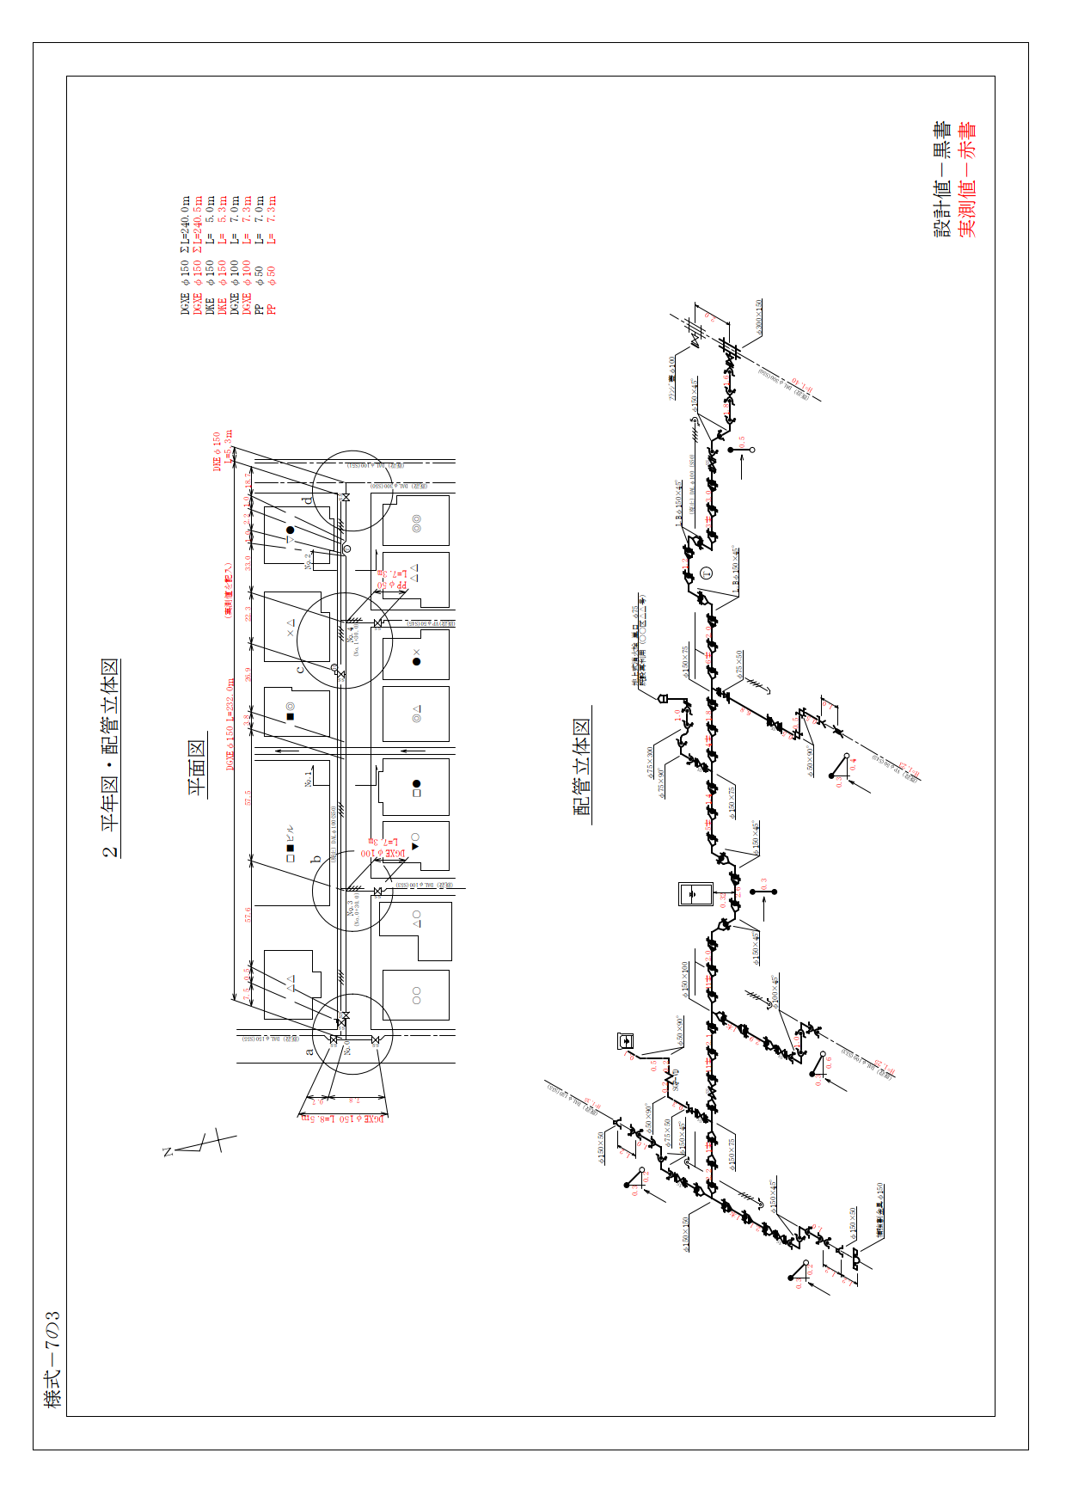

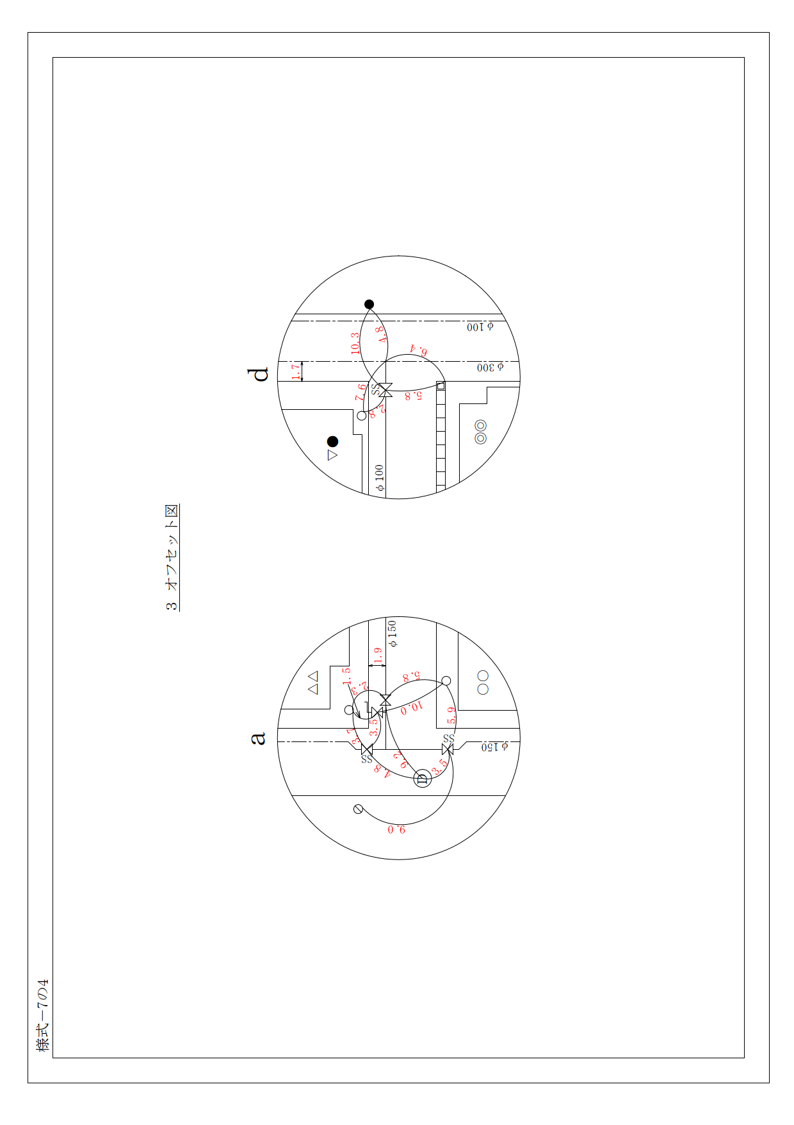

（様式-7の5）

|  |  |  |  |  |  |  |  |  |  |  |  |  |  |  |  |  |  |  |  |  |  |  |  |  |  |  |  |  |  |  |  |  |  |  |  |  |  |  |  |  |  |  |  |  |  |  |  |  |  |  |  |  |  |  |  |  |  |  |  |  |  |  |  |  |  |  |  |  |  |  |
| --- | --- | --- | --- | --- | --- | --- | --- | --- | --- | --- | --- | --- | --- | --- | --- | --- | --- | --- | --- | --- | --- | --- | --- | --- | --- | --- | --- | --- | --- | --- | --- | --- | --- | --- | --- | --- | --- | --- | --- | --- | --- | --- | --- | --- | --- | --- | --- | --- | --- | --- | --- | --- | --- | --- | --- | --- | --- | --- | --- | --- | --- | --- | --- | --- | --- | --- | --- | --- | --- | --- |
| 1  （単位　mm）   |  |  |  |  |  |  |  |  |  |  | | --- | --- | --- | --- | --- | --- | --- | --- | --- | --- | | 測定項目 | Ｗ | | | Ｈ | | | Ｈ1 | | | | 許 容 値 | -30 | | | -30 | | | ±50 | | | | 測点又は区別 | 設計値 | 実測値 | 差 | 設計値 | 実測値 | 差 | 設計値 | 実測値 | 差 | | No.0+50 | － | － | － | － | － | － | 800 | 810 | +10 | | No.1 | 550 | 550 | ±0 | 970 | 1000 | +30 | 800 | 800 | ±0 | | No.1+50 | － | － | － | － | － | － | 800 | 780 | -20 | | No.2 | 550 | 570 | +20 | 970 | 970 | ±0 | 800 | 800 | ±0 |   　　　　　　　　　　　　　　　　　　　　　　　　　　　　　　　　　　　　　　　　　　　　　　　　　　　　　　設計値―黒書  　　　　　　　　　　　　　　　　　　　　　　　　　　　　　　　　　　　　　　　　　　　　　　　　　　　　　　実測値―朱書 |

4　掘削土工・土被り管理図表（例）

（様式-7の6-1）

5　埋戻工・路盤工・仮復旧工　管理図表（例）

|  |  |  |  |  |  |  |  |  |  |  |  |  |  |  |  |  |  |  |  |  |  |  |  |  |  |  |  |  |  |  |  |  |  |  |  |  |  |  |  |  |  |  |  |  |  |  |  |  |  |  |  |  |  |  |  |  |  |  |  |  |  |  |  |  |  |
| --- | --- | --- | --- | --- | --- | --- | --- | --- | --- | --- | --- | --- | --- | --- | --- | --- | --- | --- | --- | --- | --- | --- | --- | --- | --- | --- | --- | --- | --- | --- | --- | --- | --- | --- | --- | --- | --- | --- | --- | --- | --- | --- | --- | --- | --- | --- | --- | --- | --- | --- | --- | --- | --- | --- | --- | --- | --- | --- | --- | --- | --- | --- | --- | --- | --- |
| 2  （単位　mm）   |  |  |  |  |  |  |  |  |  |  |  |  |  | | --- | --- | --- | --- | --- | --- | --- | --- | --- | --- | --- | --- | --- | | 測定項目 | Ｔ1 | | | Ｔ2 | | | Ｔ3 | | | Ｔ4 | | | | 許 容 値 |  | | | -20 | | | -20 | | |  | | | | 測点又は区別 | 設計値 | 実測値 | 差 | 設計値 | 実測値 | 差 | 設計値 | 実測値 | 差 | 設計値 | 実測値 | 差 | | No.1 | 380 | 410 | +30 | 200 | 200 | ±0 | 190 | 190 | ±0 | 30 | 30 | ±0 | | No.2 | 380 | 380 | ±0 | 200 | 210 | +10 | 190 | 180 | -10 | 30 | 30 | ±0 |   　　　　　　　　　　　　　　　　　　　　　　　　　　　　　　　　　　　　　　　　　　　　　　　　　　　　設計値―黒書  　　　　　　　　　　　　　　　　　　　　　　　　　　　　　　　　　　　　　　　　　　　　　　　　　　　　実測値―朱書 |

（様式-7の6-2）

5　埋戻工・路盤工・仮復旧工　管理図表（例）

|  |  |  |  |  |  |  |  |  |  |  |  |  |  |  |  |  |  |  |  |  |  |  |  |  |  |  |  |  |  |  |  |  |  |  |  |  |  |  |  |  |  |  |  |  |  |  |  |  |  |  |  |  |  |  |  |  |  |  |  |  |  |  |  |  |  |  |  |  |  |  |  |  |  |  |  |  |  |  |  |  |
| --- | --- | --- | --- | --- | --- | --- | --- | --- | --- | --- | --- | --- | --- | --- | --- | --- | --- | --- | --- | --- | --- | --- | --- | --- | --- | --- | --- | --- | --- | --- | --- | --- | --- | --- | --- | --- | --- | --- | --- | --- | --- | --- | --- | --- | --- | --- | --- | --- | --- | --- | --- | --- | --- | --- | --- | --- | --- | --- | --- | --- | --- | --- | --- | --- | --- | --- | --- | --- | --- | --- | --- | --- | --- | --- | --- | --- | --- | --- | --- | --- |
| 7-2  （単位　mm）   |  |  |  |  |  |  |  |  |  |  |  |  |  |  |  |  | | --- | --- | --- | --- | --- | --- | --- | --- | --- | --- | --- | --- | --- | --- | --- | --- | | 測定項目 | Ｗ | | | Ｔ1 | | | Ｔ2 | | | Ｔ3 | | | Ｔ4 | | | | 許 容 値 | -30 | | |  | | | -20 | | | -20 | | |  | | | | 測点又は区別 | 設計値 | 実測値 | 差 | 設計値 | 実測値 | 差 | 設計値 | 実測値 | 差 | 設計値 | 実測値 | 差 | 設計値 | 実測値 | 差 | | No.1 | 1500 | 1500 | ±0 | 380 | 410 | +30 | 200 | 200 | ±0 | 190 | 190 | ±0 | 30 | 30 | ±0 | | No.2 | 1500 | 1500 | ±0 | 380 | 380 | ±0 | 200 | 210 | +10 | 190 | 180 | -10 | 30 | 30 | ±0 |   　　　　　　　　　　　　　　　　　　　　　　　　　　　　　　　　　　　　　　　　　　　　　　　　　　　　　　　設計値―黒書  　　　　　　　　　　　　　　　　　　　　　　　　　　　　　　　　　　　　　　　　　　　　　　　　　　　　　　　実測値―朱書 |

（様式-7の7-1）

|  |  |  |  |  |  |  |  |  |  |  |  |  |  |  |  |  |  |  |  |  |  |  |  |  |  |  |  |  |  |  |  |  |  |  |  |  |  |  |  |  |  |  |  |  |  |  |  |  |  |  |  |  |  |  |  |  |  |  |  |  |  |  |  |  |  |
| --- | --- | --- | --- | --- | --- | --- | --- | --- | --- | --- | --- | --- | --- | --- | --- | --- | --- | --- | --- | --- | --- | --- | --- | --- | --- | --- | --- | --- | --- | --- | --- | --- | --- | --- | --- | --- | --- | --- | --- | --- | --- | --- | --- | --- | --- | --- | --- | --- | --- | --- | --- | --- | --- | --- | --- | --- | --- | --- | --- | --- | --- | --- | --- | --- | --- |
| 4  （単位　mm）   |  |  |  |  |  |  |  |  |  |  |  |  |  | | --- | --- | --- | --- | --- | --- | --- | --- | --- | --- | --- | --- | --- | | 測定項目 | Ｗ | | | Ｔ2 | | | Ｔ3 | | | Ｔ4 | | | | 許 容 値 | -30 | | | -20 | | | -20 | | |  | | | | 測点又は区別 | 設計値 | 実測値 | 差 | 設計値 | 実測値 | 差 | 設計値 | 実測値 | 差 | 設計値 | 実測値 | 差 | | No.0+30 | 550 | 710 | +160 | 200 | 220 | +20 | 190 | 190 | ±0 | 30 | 30 | ±0 | | No.1+40 | 550 | 690 | +140 | 200 | 230 | +30 | 190 | 180 | -10 | 30 | 30 | ±0 |     　　　　　　　　　　　　　　　　　　　　　　　　　　　　　　　　　　　　　　　　　　　　　　　　　　　　　　設計値―黒書  　　　　　　　　　　　　　　　　　　　　　　　　　　　　　　　　　　　　　　　　　　　　　　　　　　　　　　実測値―朱書 |

6　路　盤　検　査　結　果　表（例）

（様式-7の7-2）

|  |  |  |  |  |  |  |  |  |  |  |  |  |  |  |  |  |  |  |  |  |  |  |  |  |  |  |  |  |  |  |  |  |  |  |  |  |  |  |  |  |  |  |  |  |  |  |  |  |  |  |  |  |  |  |  |  |  |  |  |  |  |  |  |  |  |  |  |  |  |  |  |  |  |  |  |  |  |  |  |  |
| --- | --- | --- | --- | --- | --- | --- | --- | --- | --- | --- | --- | --- | --- | --- | --- | --- | --- | --- | --- | --- | --- | --- | --- | --- | --- | --- | --- | --- | --- | --- | --- | --- | --- | --- | --- | --- | --- | --- | --- | --- | --- | --- | --- | --- | --- | --- | --- | --- | --- | --- | --- | --- | --- | --- | --- | --- | --- | --- | --- | --- | --- | --- | --- | --- | --- | --- | --- | --- | --- | --- | --- | --- | --- | --- | --- | --- | --- | --- | --- | --- |
| 8-2  （単位　mm）   |  |  |  |  |  |  |  |  |  |  |  |  |  |  |  |  | | --- | --- | --- | --- | --- | --- | --- | --- | --- | --- | --- | --- | --- | --- | --- | --- | | 測定項目 | Ｗ1 | | | Ｗ2 | | | Ｔ2 | | | Ｔ3 | | | Ｔ4 | | | | 許 容 値 | -30 | | | -30 | | | -20 | | | -20 | | |  | | | | 測点又は区別 | 設計値 | 実測値 | 差 | 設計値 | 実測値 | 差 | 設計値 | 実測値 | 差 | 設計値 | 実測値 | 差 | 設計値 | 実測値 | 差 | | No.0+30 | 550 | 710 | +160 | 1500 | 1510 | +10 | 200 | 220 | +20 | 190 | 190 | ±0 | 30 | 30 | ±0 | | No.1+40 | 550 | 690 | +140 | 1500 | 1510 | +10 | 200 | 230 | +30 | 190 | 180 | -10 | 30 | 30 | ±0 |     　　　　　　　　　　　　　　　　　　　　　　　　　　　　　　　　　　　　　　　　　　　　　　　　　　　　　　設計値―黒書  　　　　　　　　　　　　　　　　　　　　　　　　　　　　　　　　　　　　　　　　　　　　　　　　　　　　　　実測値―朱書 |

6　路　盤　検　査　結　果　表（例）

（様式-7の8）

|  |  |  |  |  |  |  |  |  |  |  |  |  |  |  |  |  |  |  |  |  |  |  |  |  |  |  |  |  |  |  |  |  |  |  |  |  |  |  |  |  |  |  |  |  |  |  |  |  |  |  |  |  |  |  |  |  |  |  |  |  |  |  |  |  |  |
| --- | --- | --- | --- | --- | --- | --- | --- | --- | --- | --- | --- | --- | --- | --- | --- | --- | --- | --- | --- | --- | --- | --- | --- | --- | --- | --- | --- | --- | --- | --- | --- | --- | --- | --- | --- | --- | --- | --- | --- | --- | --- | --- | --- | --- | --- | --- | --- | --- | --- | --- | --- | --- | --- | --- | --- | --- | --- | --- | --- | --- | --- | --- | --- | --- | --- |
| （単位　mm）   |  |  |  |  |  |  |  |  |  |  |  |  |  | | --- | --- | --- | --- | --- | --- | --- | --- | --- | --- | --- | --- | --- | | 測定項目 | Ｗ | | | Ｈ | | | Ｔ1 | | | Ｔ2 | | | | 許 容 値 | -25 | | | －は認めない | | | -5 | | | -5 | | | | 測点又は区別 | 設計値 | 実測値 | 差 | 設計値 | 実測値 | 差 | 設計値 | 実測値 | 差 | 設計値 | 実測値 | 差 | | No.1 | 1,500 | 1,520 | +20 | 70 | 75 | +5 | 40 | 45 | +5 | 30 | 30 | ±0 | | No.2 | 1,500 | 1,500 | ±0 | 70 | 70 | ±0 | 40 | 40 | ±0 | 30 | 30 | ±0 |   　　　　　　　　　　　　　　　　　　　　　　　　　　　　　　　　　　　　　　　　　　　　　　　　　　　　　　設計値―黒書  　　　　　　　　　　　　　　　　　　　　　　　　　　　　　　　　　　　　　　　　　　　　　　　　　　　　　　実測値―朱書 |

7　舗　装　工　管　理　図　表（例）

（様式-7の9）

|  |  |  |  |  |  |  |  |  |  |  |  |  |  |  |  |  |  |  |  |  |
| --- | --- | --- | --- | --- | --- | --- | --- | --- | --- | --- | --- | --- | --- | --- | --- | --- | --- | --- | --- | --- |
| （単位　mm）   |  |  |  |  | | --- | --- | --- | --- | | 測定項目 | Ｈ | | | | 許 容 値 | －は認めない | | | | 測点又は区別 | 設計値 | 実測値 | 差 | | No.1 | 30 | 40 | +10 | | No.2 | 30 | 30 | ±0 |   　　　　　　　　　　　　　　　　　　　　　　　　　　　　　　　　　　　　　　　　　　　　　　　　　　　　　　　設計値―黒書  　　　　　　　　　　　　　　　　　　　　　　　　　　　　　　　　　　　　　　　　　　　　　　　　　　　　　　　実測値―朱書 |

8　オーバーレイ工管理図表（例）

（様式-7の10）

|  |  |  |  |  |  |  |  |  |  |  |  |  |  |  |  |  |  |  |  |  |  |  |  |  |  |  |  |  |  |  |  |  |  |  |  |  |  |  |  |  |  |  |  |  |  |  |  |  |  |  |  |
| --- | --- | --- | --- | --- | --- | --- | --- | --- | --- | --- | --- | --- | --- | --- | --- | --- | --- | --- | --- | --- | --- | --- | --- | --- | --- | --- | --- | --- | --- | --- | --- | --- | --- | --- | --- | --- | --- | --- | --- | --- | --- | --- | --- | --- | --- | --- | --- | --- | --- | --- | --- |
| |  |  |  |  |  | | --- | --- | --- | --- | --- | |  | a辺 | b辺 | c辺 | Ｓ | | ① | 3.0 | 4.0 | 5.0 | 6.0 | | ② | 3.0 | 4.0 | 5.0 | 6.0 | | ③ | 7.0 | 7.0 | 4.0 | 13.4 | | ④ | 8.0 | 7.0 | 2.0 | 6.4 | | ⑤ | 6.0 | 5.0 | 2.0 | 4.7 | | 合計 | | | | 36.5 |   (単位　㎡)  (単位　㎡)  ヘロンの公式   |  |  |  |  | | --- | --- | --- | --- | | 測定項目 | S | | | | 許 容 値 | －は認めない | | | | 測点又は区別 | 設計値 | 実測値 | 差 | | 監督員の指示する箇所 | 30.0 | 36.5 | + 6.5 |   S=√t(t-a)(t-b)(t-c)  ただし t=  a+b+c  2  設計値―黒書  実測値―朱書 |

8　オーバーレイ工管理図表（例）

（様式-7の11）

|  |  |  |  |  |  |  |  |  |  |  |  |  |  |  |  |  |  |  |  |  |  |  |  |  |  |  |  |  |  |  |  |  |  |  |  |  |  |  |  |  |  |  |  |  |  |  |  |  |  |  |  |  |  |  |  |  |  |  |  |  |  |  |  |  |  |  |  |  |  |  |  |  |  |  |  |  |  |  |  |  |  |  |  |  |  |  |  |  |  |  |  |  |  |  |  |  |  |  |  |  |  |  |  |  |  |  |  |  |  |  |  |  |  |  |  |  |  |  |  |  |  |  |  |  |  |  |  |  |  |  |  |  |  |  |  |  |  |  |  |  |  |  |  |  |  |  |  |  |  |  |  |  |  |  |  |  |  |  |  |  |  |  |  |  |  |  |  |  |  |
| --- | --- | --- | --- | --- | --- | --- | --- | --- | --- | --- | --- | --- | --- | --- | --- | --- | --- | --- | --- | --- | --- | --- | --- | --- | --- | --- | --- | --- | --- | --- | --- | --- | --- | --- | --- | --- | --- | --- | --- | --- | --- | --- | --- | --- | --- | --- | --- | --- | --- | --- | --- | --- | --- | --- | --- | --- | --- | --- | --- | --- | --- | --- | --- | --- | --- | --- | --- | --- | --- | --- | --- | --- | --- | --- | --- | --- | --- | --- | --- | --- | --- | --- | --- | --- | --- | --- | --- | --- | --- | --- | --- | --- | --- | --- | --- | --- | --- | --- | --- | --- | --- | --- | --- | --- | --- | --- | --- | --- | --- | --- | --- | --- | --- | --- | --- | --- | --- | --- | --- | --- | --- | --- | --- | --- | --- | --- | --- | --- | --- | --- | --- | --- | --- | --- | --- | --- | --- | --- | --- | --- | --- | --- | --- | --- | --- | --- | --- | --- | --- | --- | --- | --- | --- | --- | --- | --- | --- | --- | --- | --- | --- | --- | --- | --- | --- | --- | --- | --- | --- |
| 9-8  再生密粒度As（13F）　30mm  再生密粒度As（13）　 40mm  施工年月日　（元号） 年　　月　 日　～　 月　　日  切取年月日　（元号）　年　 月　　日  測定年月日　（元号）　年　　月　　日  （単位　mm）   |  |  |  |  |  |  |  |  |  |  |  |  |  |  |  |  |  |  |  |  |  |  | | --- | --- | --- | --- | --- | --- | --- | --- | --- | --- | --- | --- | --- | --- | --- | --- | --- | --- | --- | --- | --- | --- | | 測定項目 | T1（再生密粒度As 13F） | | | | | | | T2（再生密粒度As 13） | | | | | | | T（表層+基層） | | | | | | | | 許 容 値 | -5 | | | | | | | -5 | | | | | | | －は認めない | | | | | | | | 測点又は区別 | 設計値 | 実測値 | | | | | 差 | 設計値 | 実測値 | | | | | 差 | 設計値 | 実測値 | | | | | 差 | | 1 | 2 | 3 | 4 | 平均 | 1 | 2 | 3 | 4 | 平均 | 1 | 2 | 3 | 4 | 平均 | | No.1+12 | 30 | 33 | 34 | 32 | 32 | 32 | +2 | 40 | 41 | 40 | 39 | 40 | 40 | ±0 | 70 | 74 | 74 | 71 | 72 | 72 | +2 | | No.2+ 5 | 30 | 32 | 33 | 34 | 34 | 33 | +3 | 40 | 38 | 37 | 37 | 37 | 37 | -3 | 70 | 70 | 70 | 71 | 71 | 70 | ±0 | |  |  |  |  |  |  |  |  |  |  |  |  |  |  |  |  |  |  |  |  |  |  | |  |  |  |  |  |  |  |  |  |  |  |  |  |  |  |  |  |  |  |  |  |  |     設計値―黒書  実測値―朱書 |

9　切 取 供 試 体 厚 さ 測 定 管 理 図 表

